Scripture Study Program (Hectorville and Tranmere Parishes)

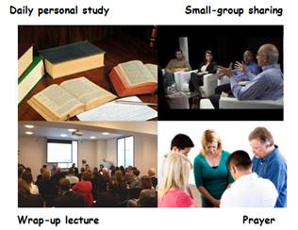

The program uses Little Rock Scripture Study resources and is intended to include a wide variety of people of all ages, backgrounds and cultures (although it is not suitable for young children). It includes four essential elements: daily personal study, weekly small-group sharing, a wrap-up video lecture, and prayer.
The length of courses varies between 4 – 15 weeks, although most are in the 7 – 10 week range. Weekly sessions are held on Tuesdays in the Tranmere Parish Hall, between 7.30 pm and 9.00 pm.
Each scripture scholar receives a Study Set for that course: a Commentary booklet that includes the Sacred Scripture; and a Study Guide booklet which assists discussion in the weekly small-group sharing. Scripture scholars are charged a small fee to cover the cost of their Study Sets.
People from other parishes and other Christian denominations are warmly welcomed.
The 2018 program is expected to include the following:
• James, Peter and Jude: The Catholic Letters
• Genesis
• The Gospel according to Mark
• The Way of Justice and Peace
For information about the program, and course bookings, please contact the Coordinator, Colleen Turk, e-mail: citurk@westnet.com.au, or phone: 8336 4099.

